H.T No
Regulations:
A15

Sreenidhi Institute of Science and Technology
(An Autonomous Institution)
Code No: 5C719 Date: 27-Jan-2023 (FN)

B.Tech IV-Year I- Semester External Examination, January-2023 (Supplementary)
Cellular and Mobile Communications (ECE)

Time: 3 Hours Max.Marks:75 Note: a) No additional answer sheets will be provided.
b) All sub-parts of a question must be answered at one place only, otherwise it will not be valued.
c) Missing data can be assumed suitably.

Bloom's Cognitive Levels of Learning (BCLL)
Remember | L1 | Apply | L3 | Evaluate | L5
Understand | L2 | Analyze | L4 | Create | L6

Part - A Max.Marks:25

Answer all QUESTIONS.
 |  | BCLL | CO(s) | Marks
1 | Compare 1G, 2G and 3G cellular standards. | L2 | CO1 | [2M]
2 | Illustrate the concept of Cell Splitting with neat diagram. | L2 | CO2 | [2M]
3 | Discuss the impact of cross talk in cellular mobile system. | L2 | CO3 | [2M]
4 | Define path loss and describe the path loss in different condition from a point to point prediction model. | L1 | CO4 | [2M]
5 | Compare hard and soft handoff with neat diagrams. | L2 | CO5 | [2M]
6 | Outline the principle of CDMA System. | L2 | CO6 | [3M]
7 | Define coherence bandwidth and Doppler spread. | L1 | CO1 | [3M]
8 | Define Reflection and Diffraction. | L1 | CO3 | [3M]
9 | Mention the two operating frequency bands of GSM system. | L1 | CO6 | [3M]
10 | What is the role of paging channels in cellular system connection establishment ? | L1 | CO4 | [3M]

Part – B Max.Marks:50
ANSWER ANY FIVE QUESTIONS. EACH QUESTION CARRIES 10 MARKS.

 |  |  | BCLL | CO(s) | Marks
11. | a) | Illustrate the operation of basic cellular wireless system with neat architecture. | L2 | CO1 | [5M]
 | b) | In a digital cellular system with operating carrier frequency f_{c}= 2400 MHz and the mobile velocity of 60 km/hr, calculate the received carrier frequency if the mobile is moving (i) at an angle of 30º with the transmitted path with positive Doppler shift (ii) in a direction perpendicular to the direction of the arrival of the transmitted signal. (iii) Discuss the effect of Doppler-shift in small scale fading for the cases (i) and (ii). | L5 | CO1 | [5M]
12. | a) | Illustrate how cellular system capacity is improved using Frequency Reuse using 7-cell frequency reuse pattern. | L2 | CO2 | [5M]
 | b) | Define Trunking and explain the two types of trunked systems used to measure grade of service parameter. | L2 | CO2 | [5M]
13. | a) | Illustrate the effects of various Antenna parameters in designing cellular system. | L2 | CO3 | [5M]
 | b) | Discuss about Near-end-Far-end interference in case of one cell and in case of two-system cells. | L2 | CO3 | [5M]
14. | a) | Derive the equation for received power calculation considering the propagation model as land-to-mobile transmission over water. | L3 | CO4 | [5M]
 | b) | In a mobile radio environment shown in Figure.1, the average cell-site antenna height (h1) is about 50 m, the mobile unit height (h2) is about 3 m and communication path length(d) is 5 km. Determine incident angle (ϴ) and elevation angle at the location of the mobile unit (ϕ’).  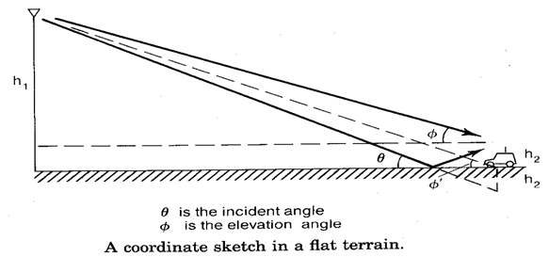  Figure.1 | L5 | CO4 | [5M]
15. | a) | Discuss the concept of frequency management concern to the numbering the channels and grouping into the subset. | L3 | CO5 | [5M]
 | b) | Define Dropped calls and explain about dropped call rates. | L2 | CO5 | [5M]
16. | a) | Illustrate the operation of three subsystems in GSM system with neat diagram. | L2 | CO6 | [5M]
 | b) | Outline the principle of TDMA and explain TDMA frame format. | L2 | CO6 | [5M]
17. | a) | Compare and contrast flat fading and frequency-selective fading. | L4 | CO1 | [4M]
 | b) | Define CCI and Determine the distance for the nearest co-channel for a cell having radius 0.8 km and a co-channel reuse factor (Q) of 7. | L3 | CO2 | [3M]
 | c) | Illustrate the concept and advantage of space diversity. | L2 | CO3 | [3M]
18. | a) | Describe the steps involved in predicting the propagation path loss in point-to-point Lee prediction model considering human-made structures in the propagation path. | L2 | CO4 | [4M]
 | b) | Write short notes on Channel Sharing and borrowing strategy. | L2 | CO5 | [3M]
 | c) | Compare and contrast FDM and OFDM. | L4 | CO6 | [3M]

-- 00 -- 00 –

